Assignment 1:

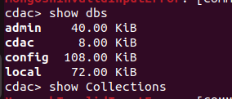
Question 6

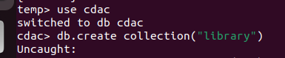
Question 7.

Question 8:


Question 9:

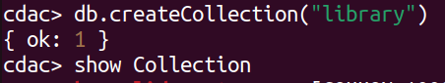

Question 10:

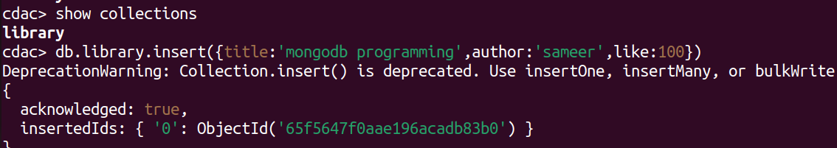

Question 11:

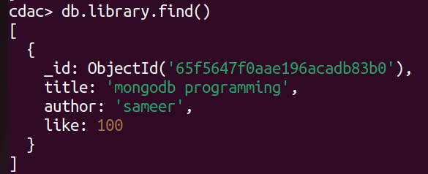

Question 12:

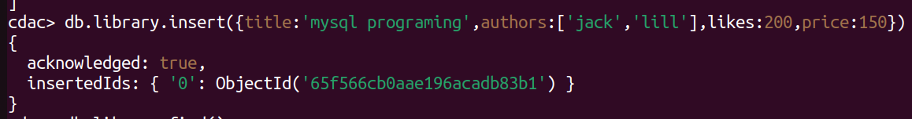
Question 13:

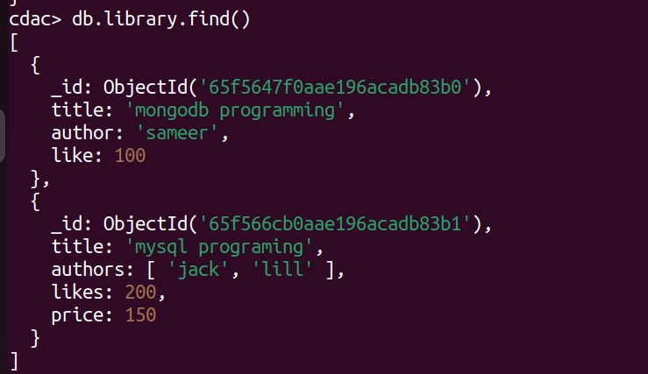

Question14:

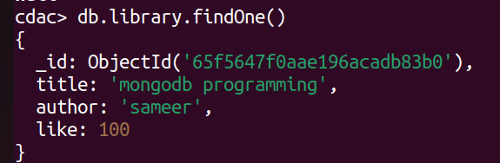
Question15:

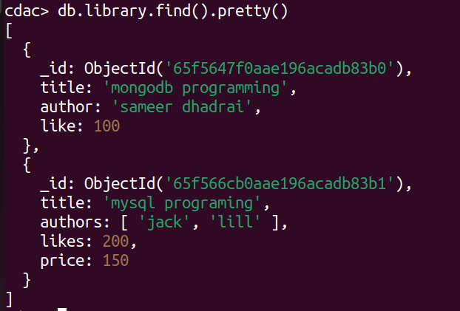

Question 16:

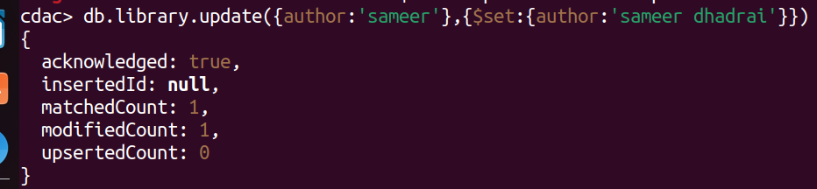
Question 17:

Question18:

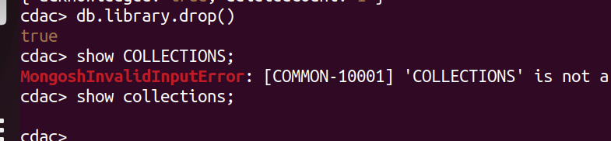
Question19:

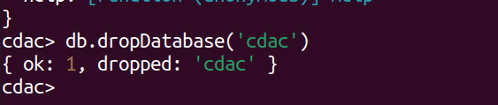
Question20:

